**Supplementary Figure 1**

A)

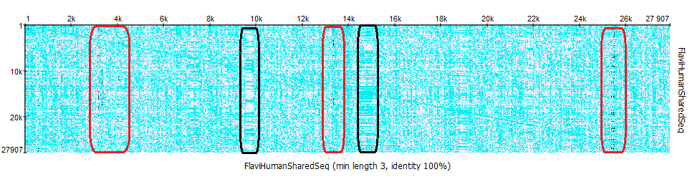

B)

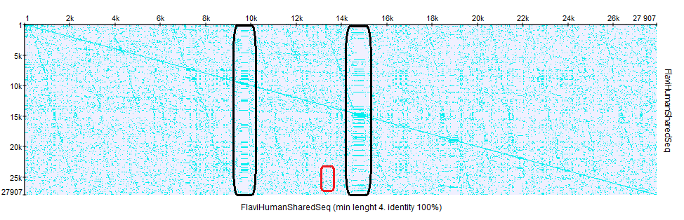

C)

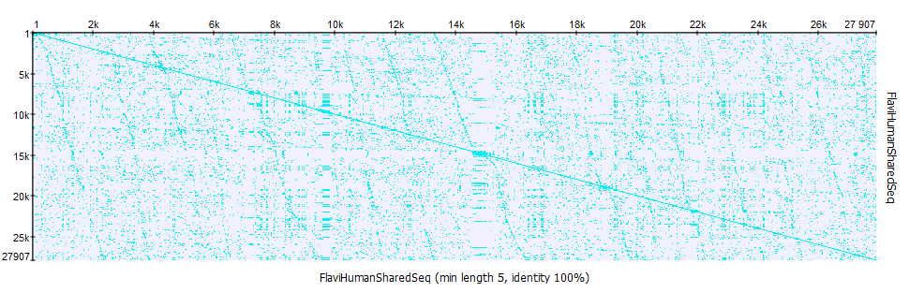

**Supplementary Figure 1:** Dot matrix of shared sequences at window lengths of three (A), four (B), and five (C) amino acid residues. Multiple direct repeat regions (blue areas) were identified in all the dot plots. A) and B) show a well-defined region of low-complexity (rectangle in black). Inverted repeats are well distinct in (A) (region rectangle in dark-red with prominent black dots).